Step1 to step4:

After installing Paython and Anaconda, opened Jupyter notebook

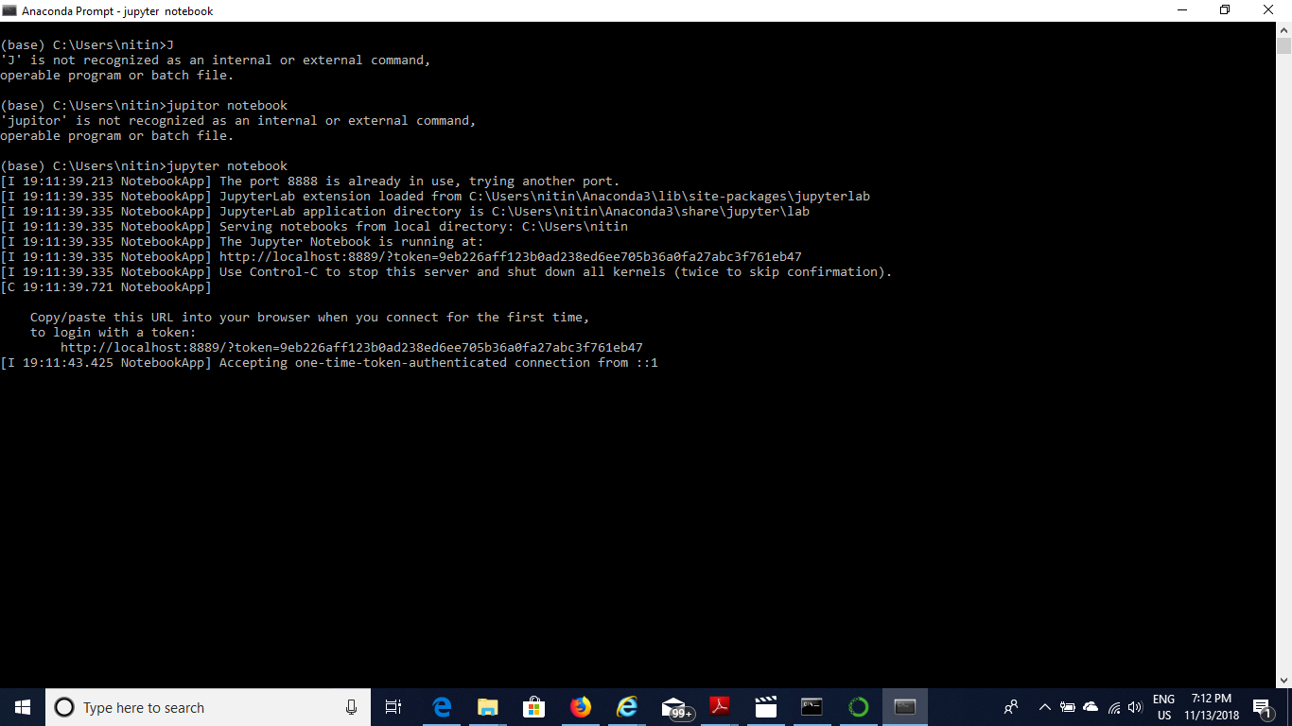

Step 5: Jupyter notebook will get open after I entered the above command and notebook

pops up as shown in the below screenshot.

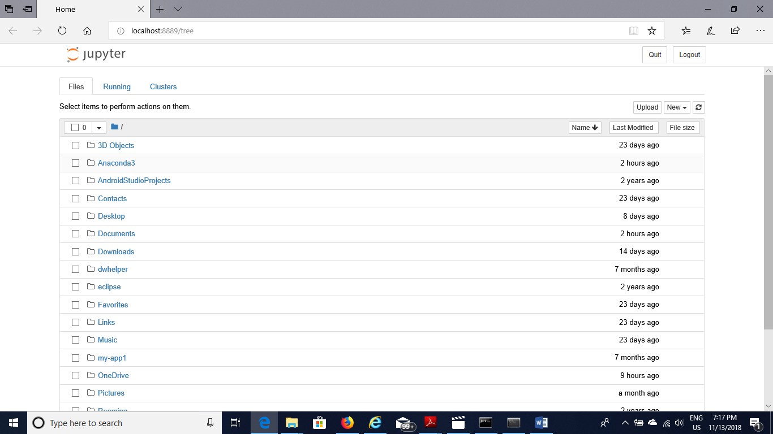

Step6: Opened Python3

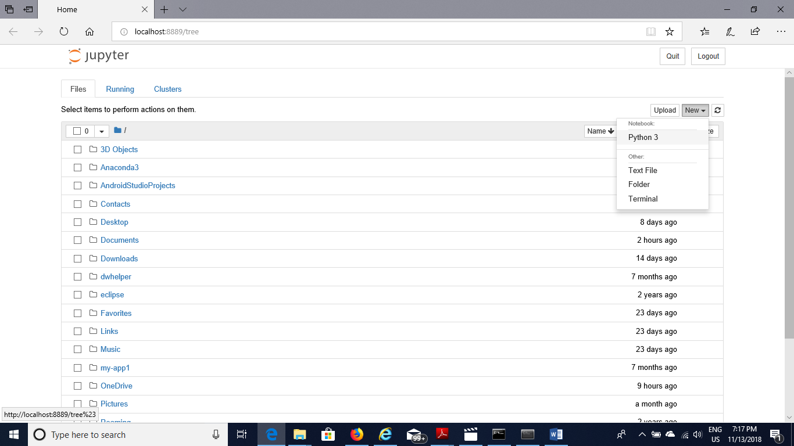

Step7: Ran some comands

